# 

**M**ind, **B**rain, and **M**odels 2022/23



Bayesian Brain Hypothesis

In this lab we will explore properties of statistical models. The goal of the exercise is to give you a feel for working with probability distributions, the problem of Bayesian Inference, but especially to teach you how to write a report.

1. *Start your lab report by indicating your student ID and the title of the lab.*
2. *Answer each of the questions after having copied it.*

We will try to account for a phenomenon in visual speed perception where low-contrast stimuli appear to move slower than high-contrast stimuli. Such a phenomenon is suspected to induce drivers to underestimate their driving speed in fog and speed up increasing the chance of accidents. The model we will implement is described in a paper, but we will not implement heavy tails (we will do it in the next lab). Stocker, A., Simoncelli, E. Noise characteristics and prior expectations in human visual speed perception. Nat Neurosci 9, 578–585 (2006). https://doi.org/10.1038/nn1669

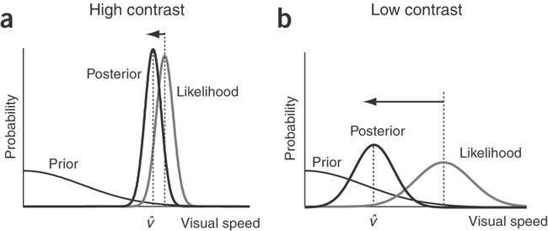

We will use the Generative model depicted on the right. The data that the observer will receive (ri) is being generated with probability:

$$p\left(r_{i}|X\right)=\frac{1}{\sqrt{2πσ^{2}}}exp\left(-\frac{{\left(r_{i}-X\right)}^{2}}{2σ^{2}}\right)$$

This is a Gaussian distribution, and it is referred to as the likelihood in the following problems. The prior expectation is also as a Gaussian distribution but with 0 mean:

$$p\left(X\right)=\frac{1}{\sqrt{2πσ^{2}}}exp\left(-\frac{X^{2}}{2σ^{2}}\right)$$

Now you will use a simple grid-based sampling approach, similar to the one adopted in Lab 1 where we tested for perception with a series of stimuli. We will compute the values of the probability function at regular interval across a range. It is rarely the case that we can realistically use such an approach, e.g. when operating in many dimensions, or with non-smooth functions. In practice, modern methods use much more complicated sampling approaches, which we will not discuss here). A normal distribution is specified by normpdf(samples,u,sigma) at the points in samples with mean u and standard deviation sigma (σ). The function requires the *Statistics and Machine Learning Toolbox* to run.  
For $r_{i}$ =2 and σ=1, calculate $p\left(r_{i}|X\right)$ with a reasonable range of samples, i.e. samples= –20:0.01:20. Likewise calculate the prior $p\left(X\right)$ with σ=2.

The posterior $p\left(X|r_{i}\right)$ is given by Bayes rule (see the slides): $p\left(X|r_{i}\right)=\frac{p\left(r_{i}|X\right)p\left(X\right)}{\int{p\left(r_{i}|X\right)p\left(X\right)dX}}$

Thus, the posterior is found by multiplying the likelihood and prior distributions. You could use a for loop, or… the operation in Matlab is performed in a single instruction using a ‘.*’ (times) rather than a ‘*’ (mtimes) operator. Please look at the manual for a clarification of what the two operations do when using an array or a matrix.

Remember that probability density functions are defined so that the integral (the area under the curve) sums to 1 or $\int_{-∞}^{∞}{p\left({X|r}_{i}\right)dX=1}$. You can do the normalization by dividing by the numerical integral of the product, the likelihood and prior (be careful of your steps in samples).   
*3) Describe your calculation to obtain the posterior probability distribution in a couple of sentences. Include a single plot with all three distributions using different colors (remember to label the axes and say what distribution each color represents). Describe what you see in the graph (especially the shape of the posterior relative to the ones of the likelihood and prior).*

Given a specific utility/gain function we can find the optimal response. Typical simple utility functions lead to estimates such as the mean, maximum or median of the posterior. Find the mean of the posterior distribution. This is **not the mean of the probability values** (y-axis), but it is a value on the x-axis. Note that for a Gaussian distribution (and all other symmetric distributions), the mean value of the distribution corresponds to the maximum, and median values.

*4) Report the mean of the posterior distribution, reasoning on its value relative to the parameters given for the likelihood.*

Now try to change the standard deviation of the likelihood two times to different values and recalculate the posterior.

*5) Report your attempts (either in the form of a table or a graph). Include the mean of the posterior distribution and the standard deviation. Label the columns of the table or the axes of the graph.*

*6) Looking at the values, write a few sentences reasoning how the values relate to each other and the mean of the likelihood. Can you spot what the relation is? Can you tell why this pattern emerges?*

*7) Finally, describe in a couple of sentences whether/how this model captures the phenomenon described by Stocker et al. We are only looking for a couple of sentences, we just want you to show that you have related the phenomenon to the model and can spot a few commonalities or differences.*

*8) Check your report, that you answered all questions, and that you have explained all graphs. Comment your code and submit it together with the report.*